# Algorithm for file updates in Python

## Project description

In this project I have been tasked with creating a Python program that compares two lists, one of allowed ip’s to a system and the other the remove list, that has IP’s to be removed from access privileges. This, to update the users allowed to access patient information in a health care provider.

## Open the file that contains the allow list

So, first, I open the file with the ‘with’ and ‘open’ commands:

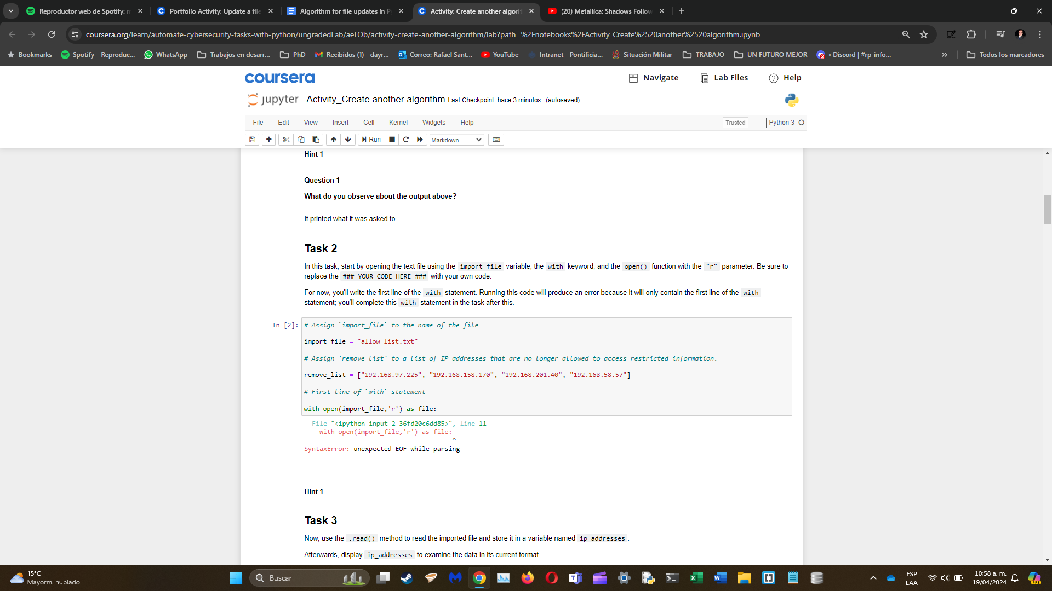

## Read the file contents

Then I read the contents of the document with the ‘. read()’ function:

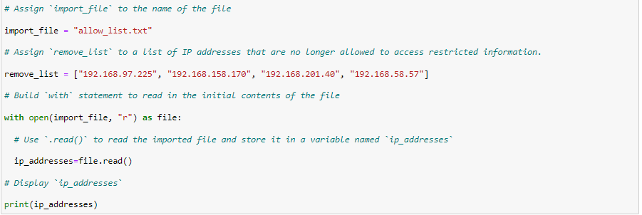

## Convert the string into a list

Then I turn the contents currently stored as a string into a list for Python to easily parse the data with the ‘.split()’ function:

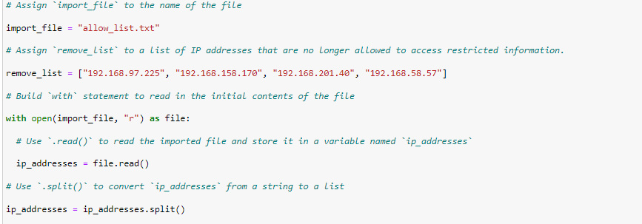

## Iterate through the remove list

Then I write an iterative statement with a ‘for’ loop to the remove list:

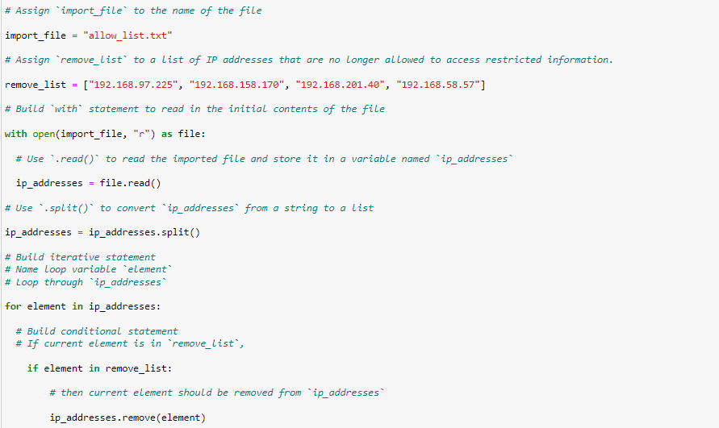

## Remove IP addresses that are on the remove list

Then I call a ‘.remove()’ function inside the conditional to remove the required users:



## Update the file with the revised list of IP addresses

Then I open the file combining ‘with’ and ‘open’ to write the revised list with the ‘.write()’ function:

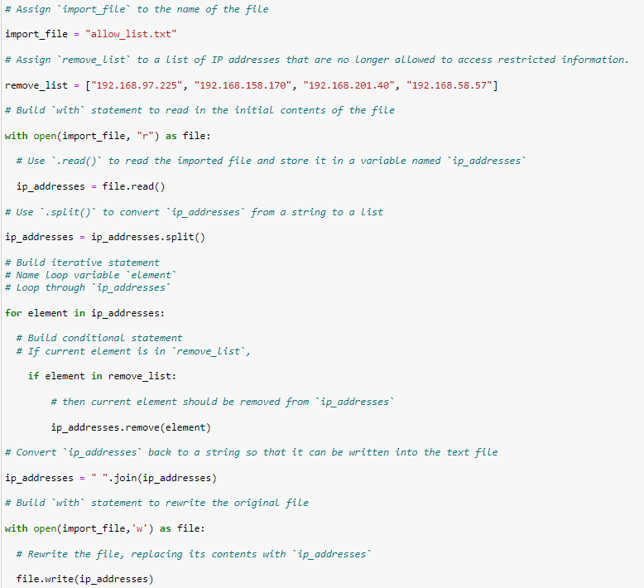

## Summary

In this exercise I wrote a functional code in Python to be used in a common cybersecurity task.